# Module 11: Dark Web Forensics Screenshots

Lara Alofi

2110886

Y

Computer Hacking Forensic Investigator (CHFI)

Lab Session Identifiers

1. <https://labclient.labondemand.com/LabClient/645b10cc-3250-4230-8f7d-862784ac31bf>

Username on EC-Council System

1. 2110886@uj.edu.sa

Lab 01

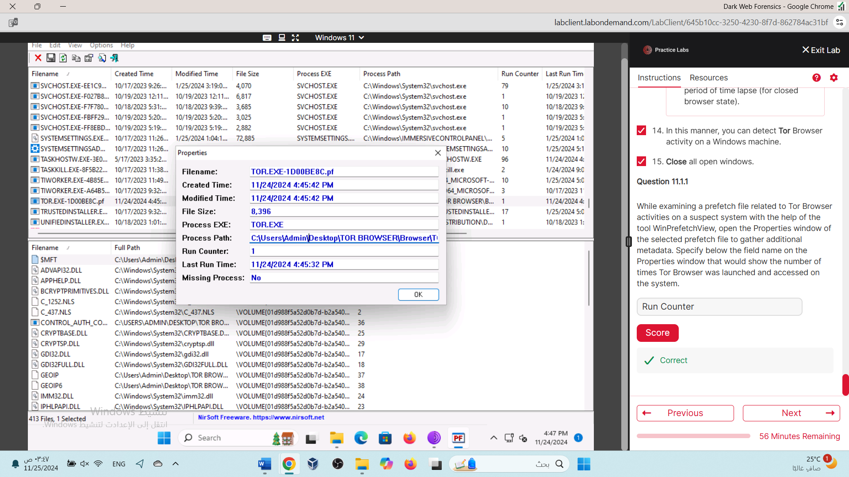

Lab 02



